
Employee Attrition Prediction
Using Machine Learning With Python

is a Course Based Project in partial fulfillment of the requirements for the
Course name: Machine Learning with Python
Course code: E1PY210B
Program: Python
Semester: II
Section: 14

SUBMITTED BY:
- Abdillahi Mahdi Ibrahim (25SCSE2160065)

SUBMITTED TO:
SCHOOL OF COMPUTER APPLICATIONS & TECHNOLOGY (SCAT)

DECLARATION
I hereby declare that the project report entitled “Employee Attrition Prediction” submitted to School of Computer Applications & Technology, Galgotias University in partial fulfillment of the requirement for the award for the degree of Master of Science (M.Sc.) in Data Analytics, is an authentic and original work carried out by me
The matter embodied in this project is a genuine work done by me and has not been submitted whether to this institute or to any other University / Institute for the fulfillment of the requirements of any course of study.
Wherever I/We have used materials (data, mathematical analysis and text) from other sources or have quoted written materials, I have given due credit to them by giving their details in the references section.
Name | Enrollment No. | Role | Sign.
Abdillahi Mahdi Ibrahim | 25scse2160065 | Project Leader & Machine Learning Developer

(Signature of approving Faculty Member)
Ms./Mr./Dr. …….…………………….
(Emp ID)………………….………...
(Affiliation)……………….………...

ACKNOWLEDGEMENT
First of all, I would like to pay my humble respect to the Almighty God for His grace and mercy, by which I was able to complete this project.
I would like to express my heartfelt gratitude to Prof. (Dr.) Vineeta Khemchandan, Dean, School of Computer Applications & Technology, Galgotias University, for the profound and continuous support provided throughout this project.
Further, I express a deep sense of gratitude to Dr. Jha Gautam Kumar
Program Chair – M.Sc. Data Analytics, School of Computer Applications & Technology, Galgotias University, for their cordial guidance and support and for making available all the required resources and materials necessary to complete this project.
I would like to extend my sincere gratitude to Ms./Mr./Dr. Jha Gautam Kumar, [Affiliation/Designation], School of Computer Applications & Technology, Galgotias University, for valuable guidance, constructive suggestions, and continuous support in completing this project.
I would also like to express my sincere thanks to Mr./Dr. Siddharth Dhirendra,
Lab Instructor, School of Computer Applications & Technology, Galgotias University, for their technical assistance, valuable suggestions, and support during the practical implementation of this project.
I also acknowledge the encouragement and support of my parents, fellow students, friends, family members, and all those who were directly or indirectly associated with the successful completion of this project.

Date: ….……………… | Name:- …...…….……………….
Signature ..……………………… | Enrollment No. …….………

Table of Contents
Contents
Introduction (Preliminary Project Plan) 5
i. Problem statement 6
ii. Objective 6
iii. Proposed Methodology 7
The project follows a structured, six-stage machine learning pipeline: 7
iv. Expected Outcome 8
v. Future-scope and Limitations 8
5.1 Future Scope 8
5.2 Current Limitations 8
Technical Requirements & Design 9
1. Libraries and Dependencies 9
Installation Command 9
2. Software Requirements 9
3. Hardware Requirements 10
4. Workflow Diagram 10
5. Database Schema 11
Technology Readiness: Implementation & Debugging 12
Dataset Collection 12
Data Preprocessing 12
Exploratory Data Analysis (EDA) 12
16
Model Development 16
Logistic Regression 16
Random Forest Classifier 17
Model Training 18
Model Evaluation 18
Debugging and Testing 19
Final product: Output screens 20
Screen 1 — Dataset Overview 20
Screen 2 — Data Visualisation 21
Screen 3 — Model Performance Metrics 24
Screen 4 — Prediction Interface 29
GitHub & Deployment details 32
GitHub Repository 32
Repository Structure 32
Deployment Details 33
Conclusion & Discussions 34
Bibliography & References 35
Appendix A: Dataset Information 36
Appendix B: Software and Tools Used 36
Appendix C: Machine Learning Models 36
Logistic Regression 36
Random Forest Classifier 36
Appendix D: Sample Code 37
Loading Dataset 37
Appendix E: Project Screenshots 37
Appendix F: Abbreviations 37
Appendix G: Future Enhancements 38

Table of Figures

Figure 1_Employee_Attrition_Distribution 9
Figure 2_Distribution_of_Employee_Ages 9
Figure 3_Distribution_of_Employee_Monthly_Income 10
Figure 4_Attrition_by_Overtime 10
Figure 5_Attrition_by_Department 11
Figure 6_Attrition_by_Department 11
Figure 7_Correlation_Heatmap 12
Figure 8_Logistic_Regression 13
Figure 9_Random_Forest 13
Figure 10_Confusion_matrix 14
Figure 11_Dataset Overview1 16
Figure 12_Dataset Overview 2 16
Figure 13_Exploratory Data Analysis 1 17
Figure 14_Exploratory Data Analysis_2 17
Figure 15_Exploratory Data Analysis_3 18
Figure 16_Exploratory Data Analysis _4 18
Figure 17_Exploratory Data Analysis_5 19
Figure 18_Exploratory Data Analysis_6 19
Figure 19_Exploratory Data Analysi_s7 20
Figure 20_Model Training_1 21
Figure 21_Model Training_2 21
Figure 22_Model Training _3 22
Figure 23_Model Training_4 22
Figure 24_Model Training_5 23
Figure 25_Model Training_6 23
Figure 26_Model Training_7 24
Figure 27_Model Training_8 24
Figure 28_Model_Evaluation_Results_1 25
Figure 29_Model_Evaluation_Results_2 26
Figure 30_Model_Evaluation_Results_3 26
Figure 31_Model_Evaluation_Results_4 27

Chapter- 1

Introduction (Preliminary Project Plan)
Employee attrition refers to the phenomenon whereby employees voluntarily or involuntarily exit an organization through resignation, retirement, or termination. High attrition rates present a significant operational and financial challenge, leading to increased recruitment costs, diminished productivity, and loss of institutional knowledge.

This project leverages machine learning algorithms to predict whether an individual employee is at risk of leaving the organization. By proactively identifying high-risk employees, HR departments can implement targeted retention strategies, thereby reducing overall turnover and its associated costs.

The dataset used in this project is sourced from Kaggle and contains a comprehensive set of employee attributes including age, monthly income, department, job role, years of experience, and satisfaction levels. These features collectively serve as predictors for the target variable — employee attrition.

Problem statement

Employee attrition is a persistent challenge across industries. The unplanned departure of skilled employees disrupts workflows, burdens remaining staff, and escalates costs associated with hiring and onboarding replacements.

This project addresses the need for a data-driven solution: developing a machine learning model capable of accurately predicting whether an employee will leave the organization based on historical employee data. The resulting system is intended to support HR professionals in making informed, evidence-based workforce decisions.

Objective
The key objectives of this project are:
- Conduct thorough analysis of employee-related data to uncover trends and patterns.
- Identify and quantify the key factors contributing to employee attrition.
- Preprocess and clean the dataset to ensure model reliability.
- Build and train a robust machine learning classification model.
- Evaluate model performance using standard metrics including accuracy, precision, and recall.
- Provide actionable insights to help organizations design effective employee retention programmers.

Proposed Methodology

The project follows a structured, six-stage machine learning pipeline:

01 | Data Collection  Download the Kaggle Employee Attrition Dataset and load it into the Python environment using Pandas.

02 | Data Preprocessing  Handle missing values, remove duplicate records, encode categorical variables using Label Encoding, and scale numerical features.

03 | Exploratory Data Analysis (EDA)  Analyses employee demographics, visualise attrition distributions, and identify the most influential features.

04 | Model Building  Split the dataset into training (80%) and testing (20%) subsets and train classification models.

05 | Model Evaluation  Compute accuracy, generate a confusion matrix, and compare model performance across algorithms.

06 | Prediction  Apply the trained model to new employee records to generate attrition predictions.

Expected Outcome
Upon successful completion of this project, the following outcomes are anticipated:

- Accurate classification of employees as likely or unlikely to leave.
- Clear identification of the features that most strongly influence attrition.
- Enhanced workforce planning capabilities for HR departments.
- Development of data-driven employee retention strategies.
- A reusable, extensible codebase suitable for integration into broader HR systems.

Future-scope and Limitations

5.1 Future Scope
- Deploy the trained model as an interactive web application using Flask or Streamlit.
- Integrate with live HR information systems to enable real-time attrition monitoring.
- Extend the model with advanced algorithms such as XGBoost, LightGBM, or deep neural networks.
- Develop dedicated HR dashboards providing visual, decision-ready insights.
- Implement automated alert systems to notify managers when employee risk scores exceed defined thresholds.

5.2 Current Limitations
- Model accuracy is contingent on the completeness and quality of the underlying dataset.
- Findings may not generalise uniformly across all industries or organisational contexts.
- A constrained feature set may limit the model's predictive depth.
- Historical data may not fully capture emerging workforce dynamics or cultural shifts.

Chapter- 2

Technical Requirements & Design

Libraries and Dependencies
The following Python libraries are required for this project:

Library | Version | Purpose
Pandas | Latest | Data manipulation and analysis
NumPy | Latest | Numerical computing
Matplotlib | Latest | Static data visualisation
Seaborn | Latest | Statistical data visualisation
Scikit-Learn | Latest | Machine learning algorithms and utilities
Joblib | Latest | Model serialisation and persistence

Installation Command
pip install pandas numpy matplotlib seaborn scikit-learn joblib

Software Requirements
Software | Purpose
Python 3.x | Core programming language
Jupyter Notebook | Interactive development environment
VS Code | Source code editor
Git | Version control system
GitHub | Remote repository hosting

Hardware Requirements
Component | Minimum Specification
Processor | Intel Core i3 or equivalent
RAM | 4 GB (8 GB recommended)
Storage | 10 GB free disk space
Operating System | Windows 10 / Ubuntu 20.04 / macOS 11+

Workflow Diagram

Database Schema
The dataset fields used as model inputs and the target variable are defined below:

Field Name | Data Type | Description
EmployeeID | Integer | Unique employee identifier
Age | Integer | Age of the employee (years)
Gender | Categorical | Employee gender
Department | Categorical | Organisational department
JobRole | Categorical | Employee's specific job role
MonthlyIncome | Float | Gross monthly salary
YearsAtCompany | Integer | Total tenure at the organisation
JobSatisfaction | Integer | Satisfaction score (1–4 scale)
Attrition | Binary | Target variable: Yes (leaves) / No (stays)

Chapter- 3

Technology Readiness: Implementation & Debugging

Dataset Collection
The Employee Attrition Prediction dataset was obtained from Kaggle. The dataset contains employee-related information such as age, department, monthly income, job role, years at company, job satisfaction, and attrition status. This dataset was used to develop and evaluate machine learning models for predicting employee attrition.

Data Preprocessing
Before building the machine learning models, the dataset was preprocessed to improve data quality and ensure accurate predictions. The dataset was loaded into Python using the Pandas library. Missing values and duplicate records were checked and handled appropriately. Categorical variables were converted into numerical values using encoding techniques. The features and target variables were then separated for model training.
The following preprocessing tasks were performed:
- Handling missing values
- Removing duplicate records
- Encoding categorical variables
- Feature and target variable separation
- Data validation and cleaning

Exploratory Data Analysis (EDA)
Exploratory Data Analysis (EDA) was conducted to understand the structure of the dataset and identify patterns related to employee attrition. Various charts and graphs were created to visualize the distribution of employee data and determine the factors that may influence attrition.
The following visualizations were generated:
- Employee Attrition Distribution
- Department-wise Attrition Analysis
- Monthly Income Distribution
- Job Satisfaction Analysis
- Employee Age Distribution
- Correlation Heatmap
The analysis provided valuable insights into employee behavior and helped in selecting important features for model development.

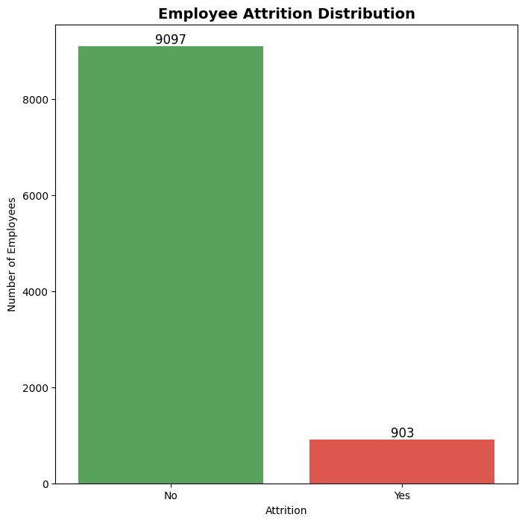
Figure 1_Employee_Attrition_Distribution
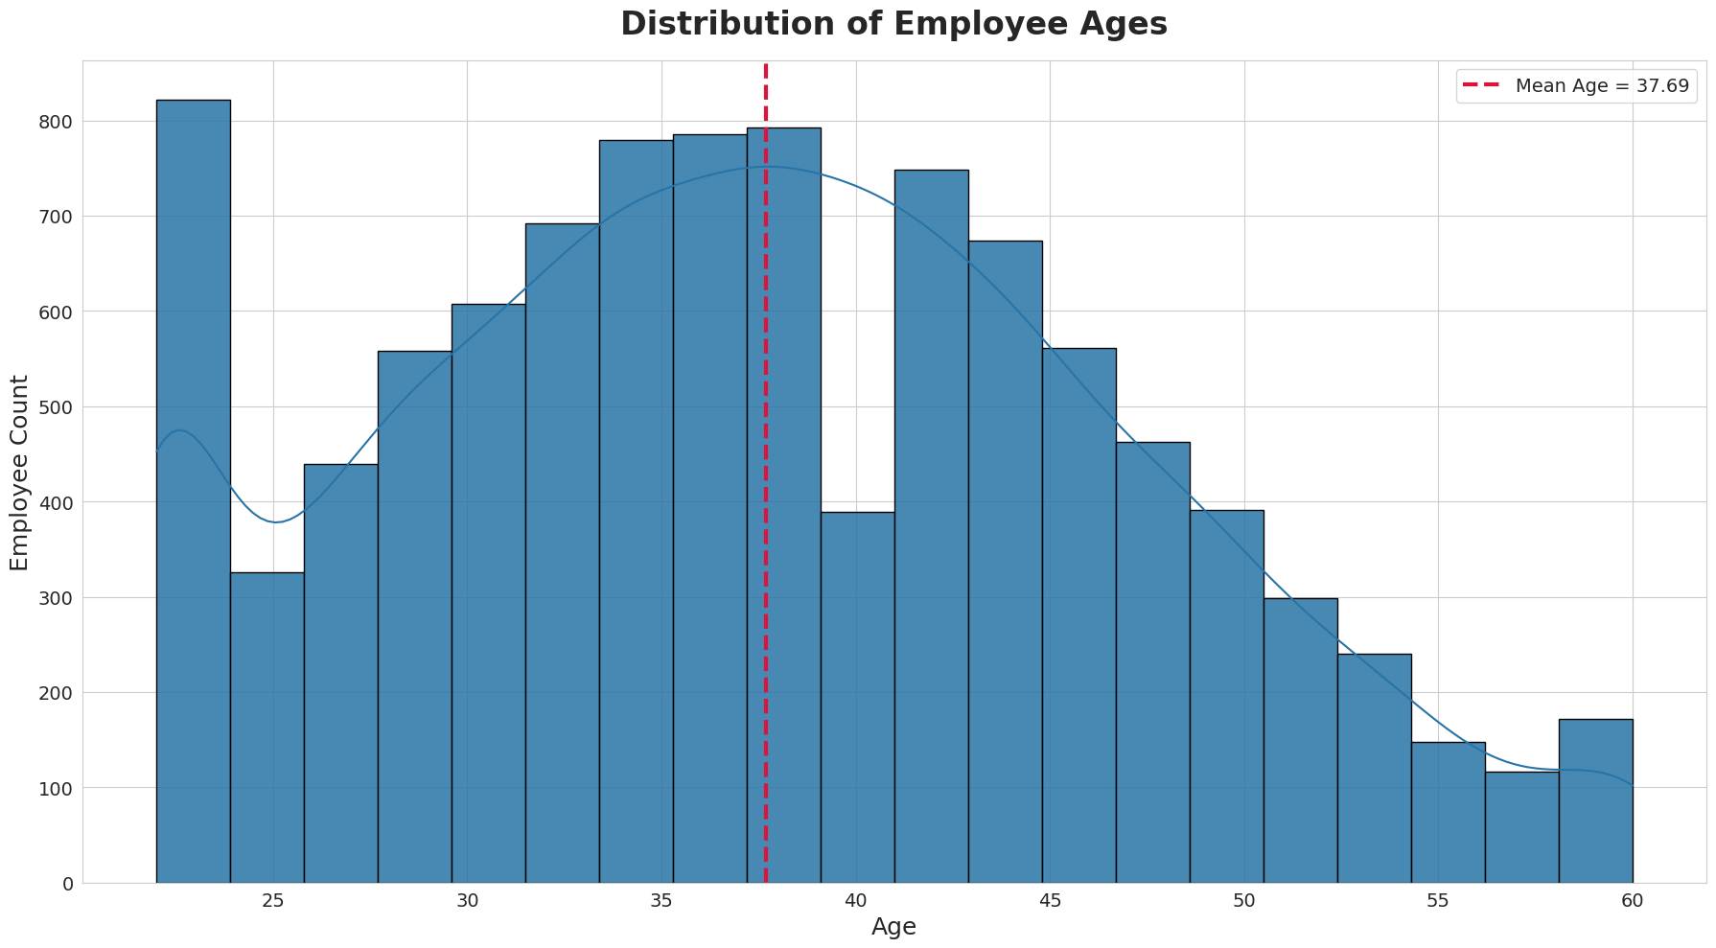
Figure 2_Distribution_of_Employee_Ages
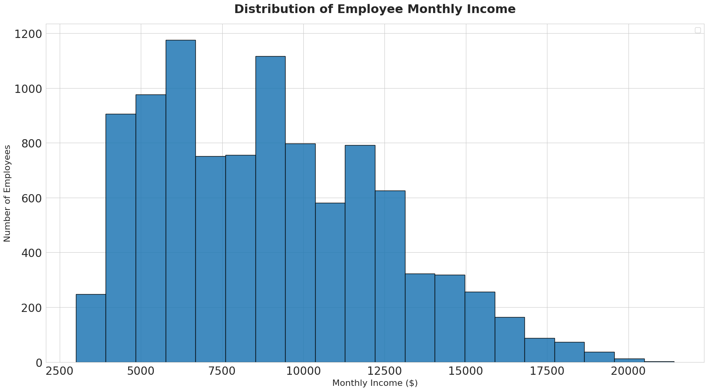
Figure 3_Distribution_of_Employee_Monthly_Income

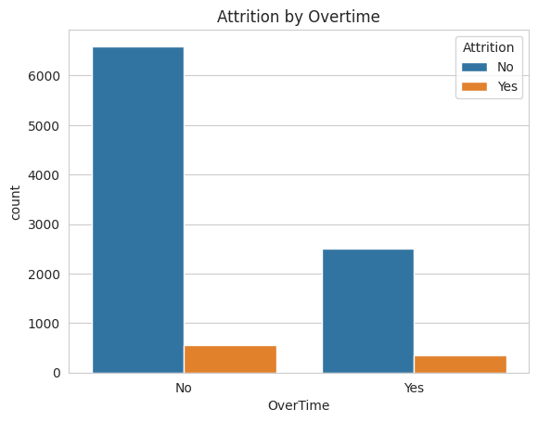
Figure 4_Attrition_by_Overtime
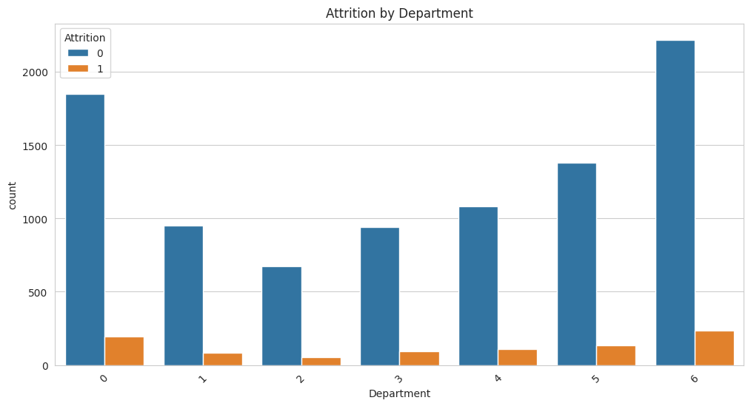
Figure 5_Attrition_by_Department

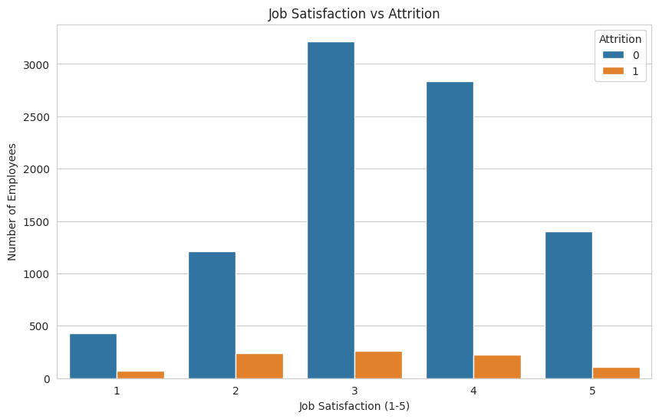
Figure 6_Attrition_by_Department
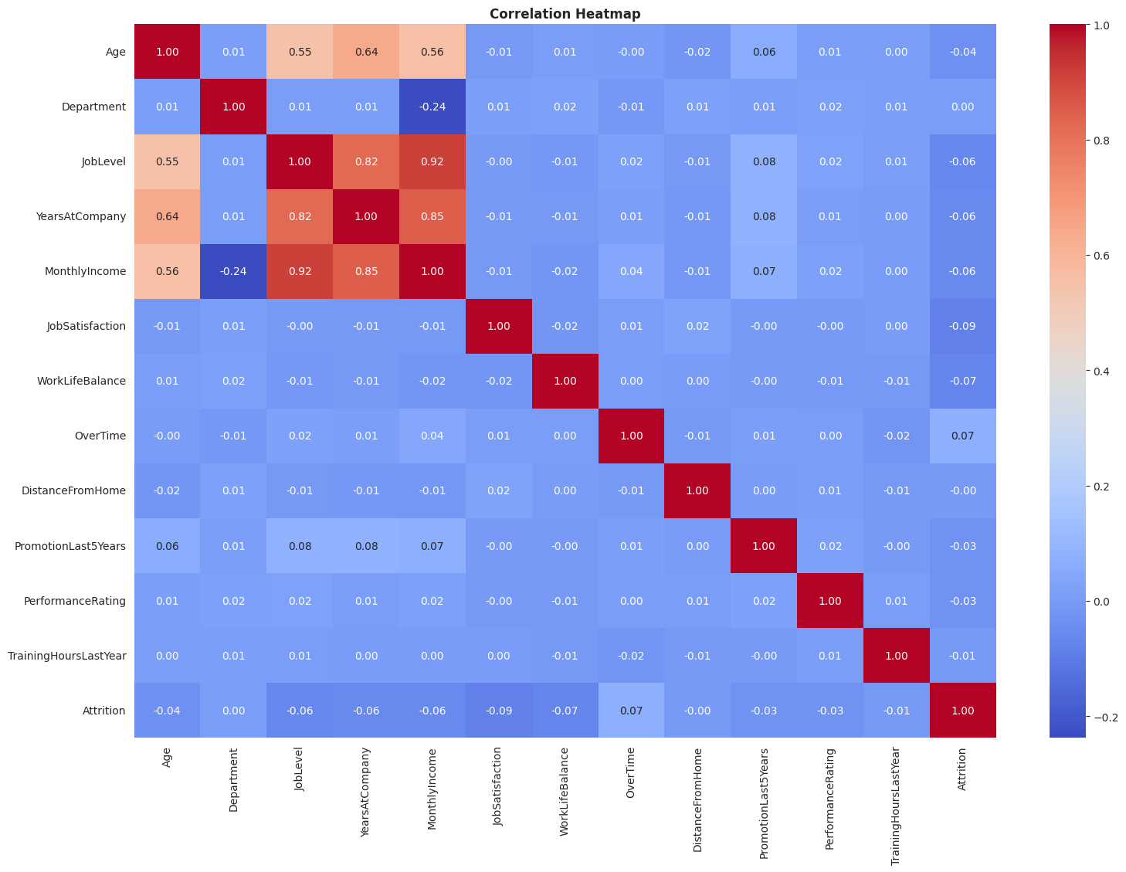
Figure 7_Correlation_Heatmap

Model Development
Two machine learning algorithms were implemented for employee attrition prediction.

Logistic Regression
Logistic Regression was used as a baseline classification algorithm. It predicts whether an employee is likely to stay or leave the organization based on the available employee information.
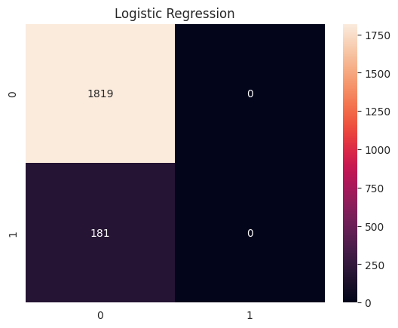
Figure 8_Logistic_Regression

Random Forest Classifier
Random Forest Classifier was implemented as an advanced machine learning model. It combines multiple decision trees to improve prediction accuracy and reduce overfitting.
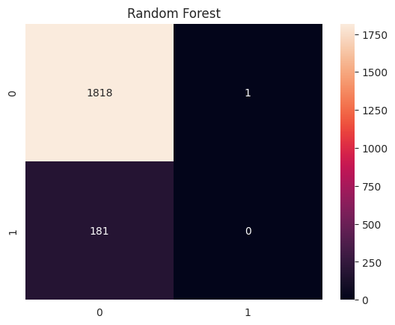
Figure 9_Random_Forest

Model Training
The dataset was divided into training and testing datasets using an 80:20 ratio. The training dataset was used to train the machine learning models, while the testing dataset was used to evaluate their performance on unseen data.
The training process involved:
- Loading the processed dataset
- Splitting the data into training and testing sets
- Training Logistic Regression
- Training Random Forest Classifier
- Generating predictions for evaluation

Model Evaluation
The performance of both machine learning models was evaluated using standard classification metrics. These metrics helped determine the effectiveness of each model in predicting employee attrition.
The following evaluation metrics were used:
- Accuracy
- Precision
- Recall
- F1-Score
- Confusion Matrix
The results obtained from Logistic Regression and Random Forest were compared to identifying the best-performing model.
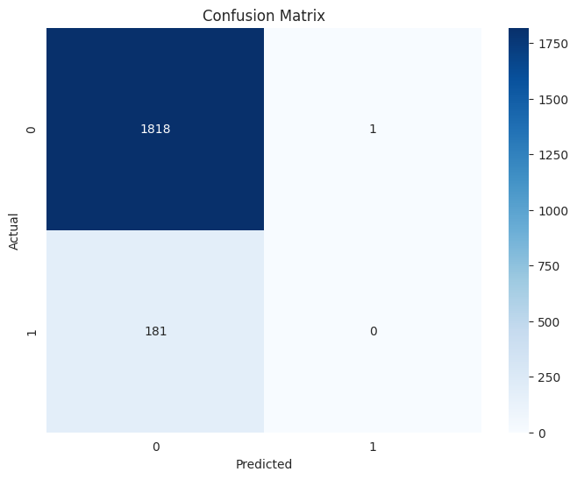
Figure 10_Confusion_matrix

Debugging and Testing
Several testing and debugging activities were performed throughout the implementation process. The project was tested to ensure that all preprocessing, training, and prediction steps were executed correctly.
The following issues were identified and resolved:
- Missing value handling
- Data type conversion errors
- Feature encoding issues
- Prediction validation errors
- Model performance verification
After successful testing and debugging, both machine learning models were able to generate accurate predictions and complete the employee attrition prediction process successfully.

Chapter- 4

Final product: Output screens
The final application presents the following key views:

Screen 1 — Dataset Overview
- Total number of employee records
- Number of input features
- Attrition distribution (Yes vs. No ratio)

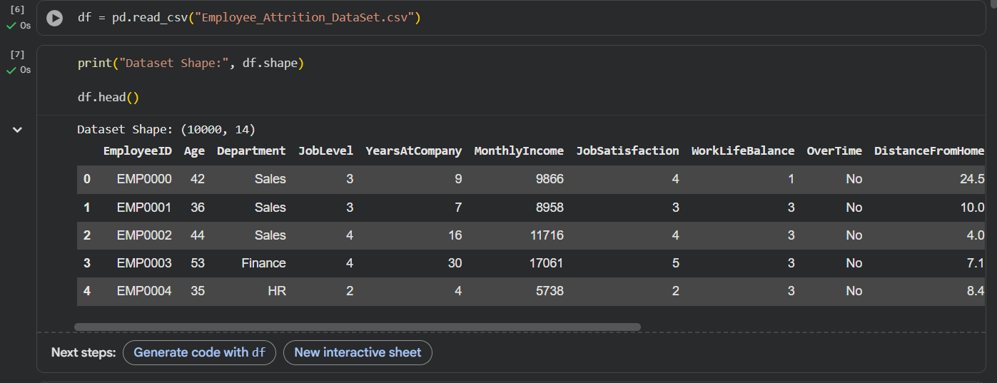
Figure 11_Dataset Overview1
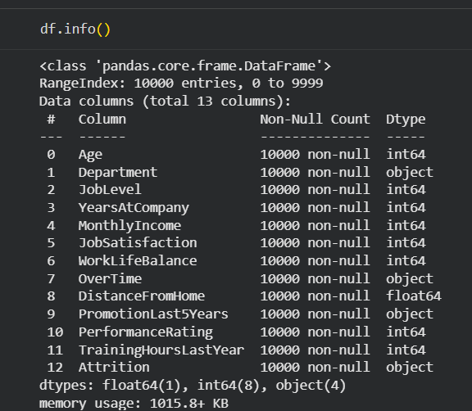
Figure 12_Dataset Overview 2

Screen 2 — Data Visualisation
- Attrition count plot
- Department-wise attrition breakdown
- Monthly income distribution

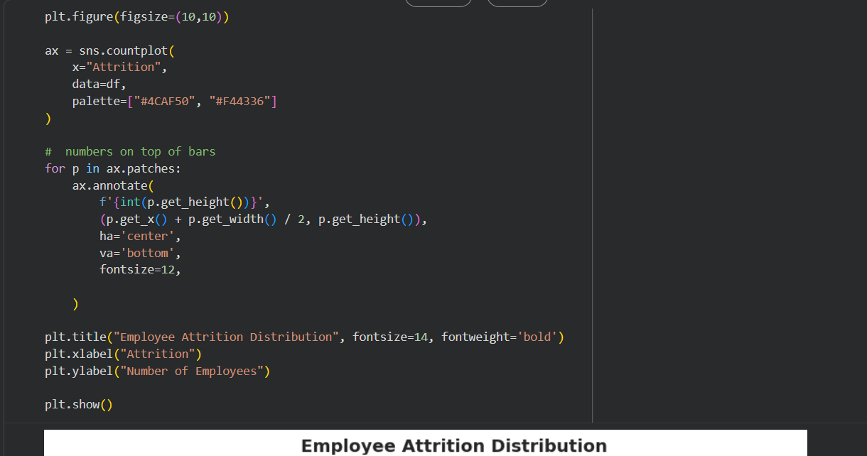
Figure 13_Exploratory Data Analysis 1
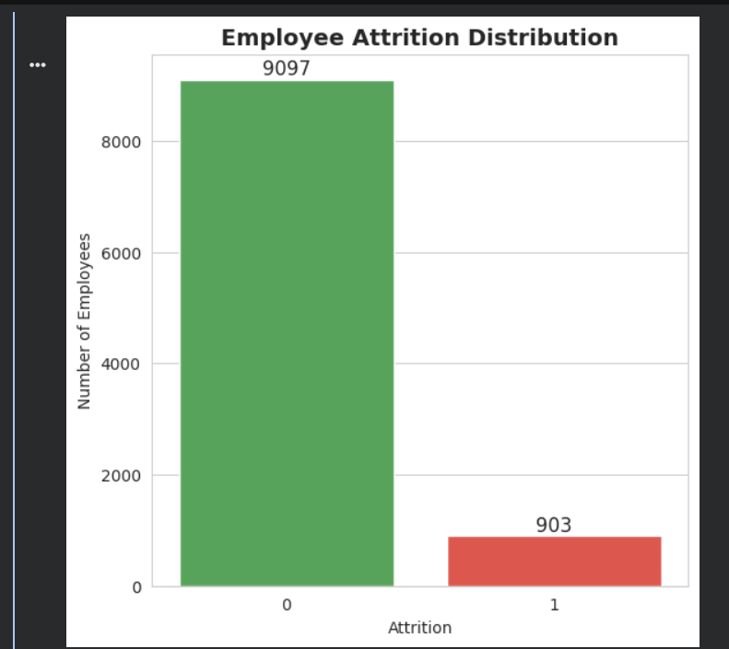
Figure 14_Exploratory Data Analysis_2

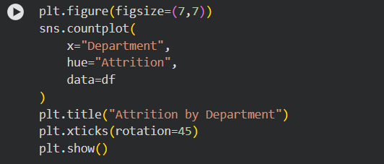
Figure 15_Exploratory Data Analysis_3
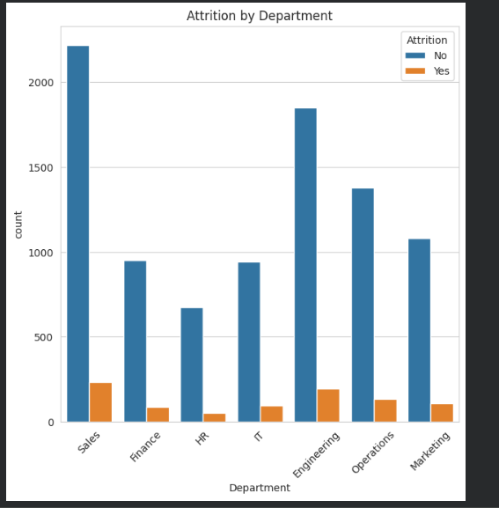
Figure 16_Exploratory Data Analysis _4

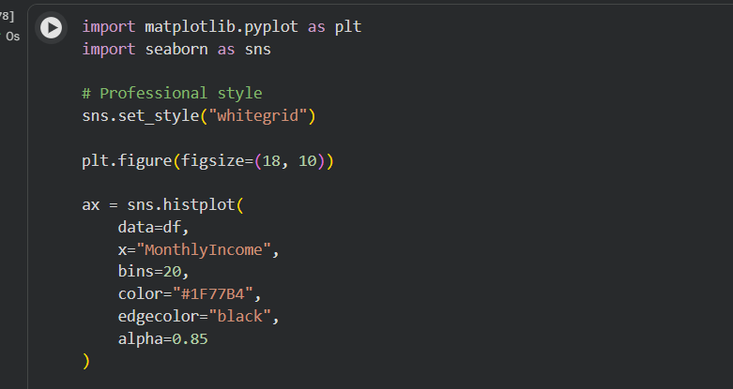
Figure 17_Exploratory Data Analysis_5
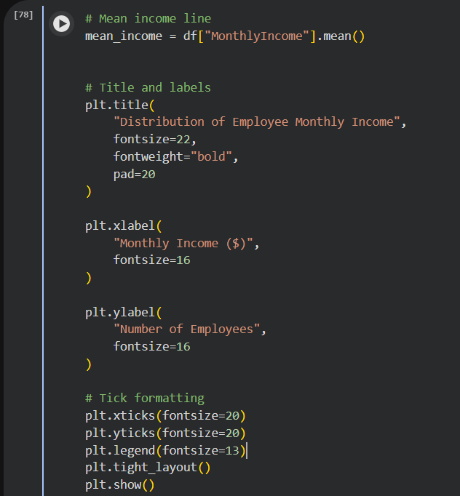
Figure 18_Exploratory Data Analysis_6
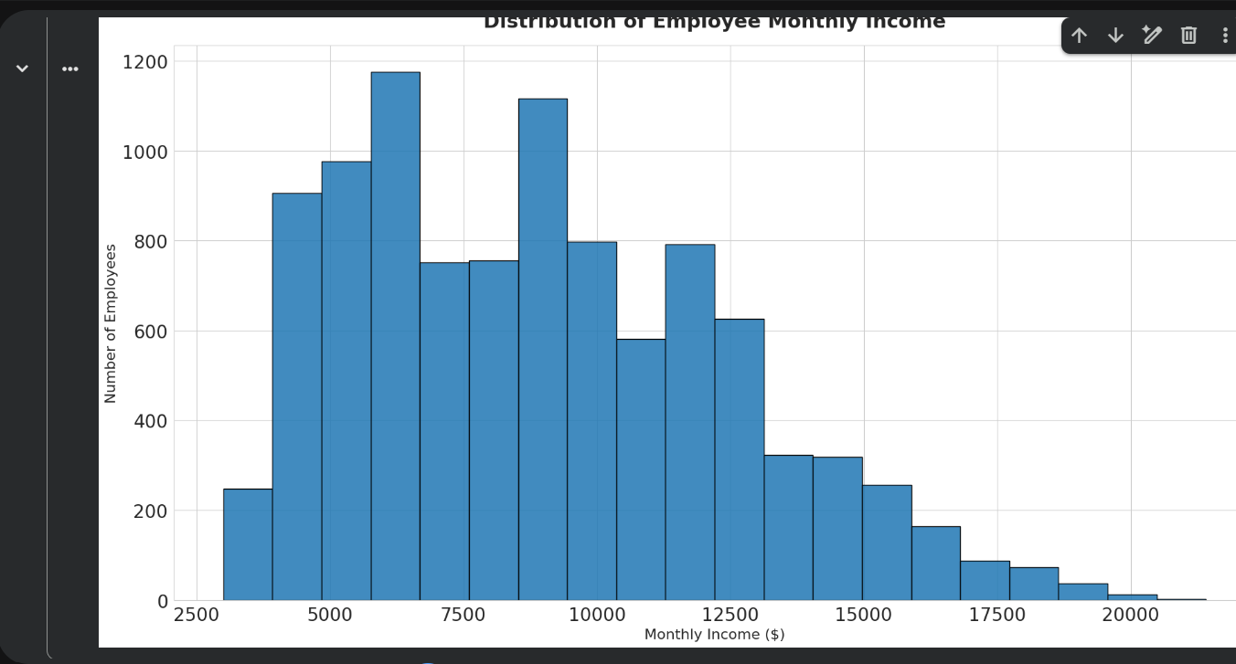
Figure 19_Exploratory Data Analysi_s7

Screen 3 — Model Performance Metrics
Metric | Description
Accuracy Score | Overall percentage of correct predictions
Precision Score | Proportion of predicted positives that are truly positive
Recall Score | Proportion of actual positives correctly identified
Confusion Matrix | Visual breakdown of true/false positives and negatives
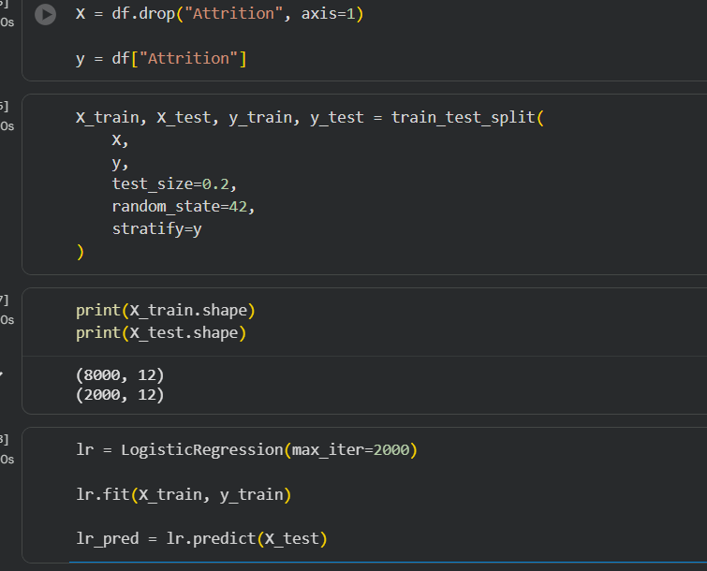
Figure 20_Model Training_1
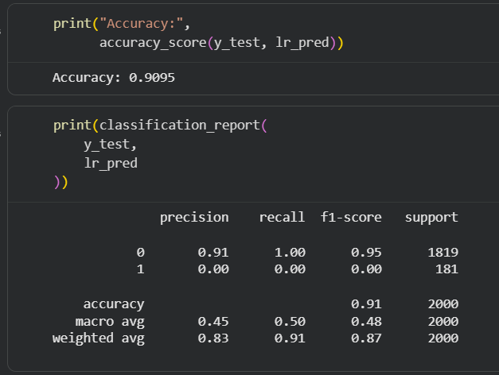
Figure 21_Model Training_2
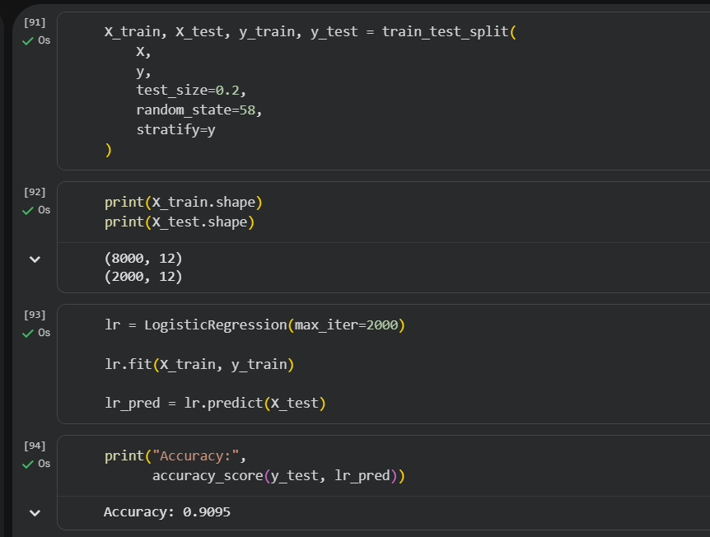
Figure 22_Model Training _3
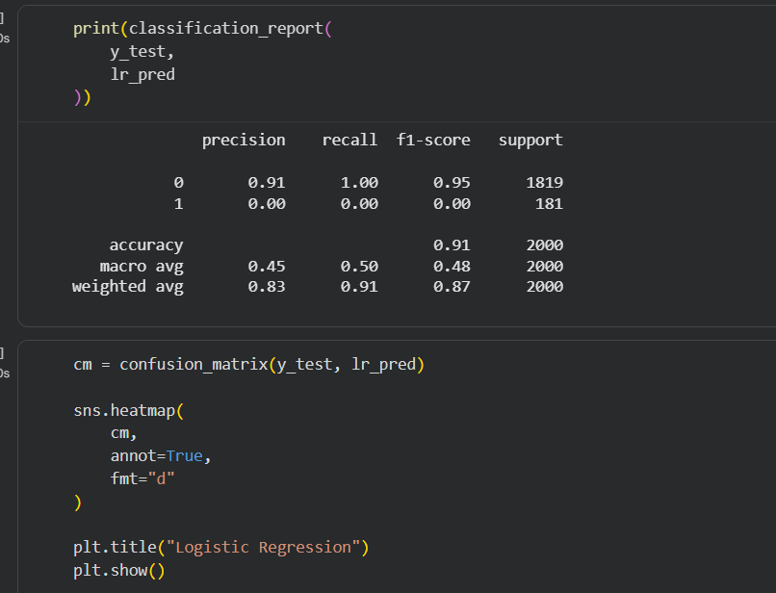
Figure 23_Model Training_4
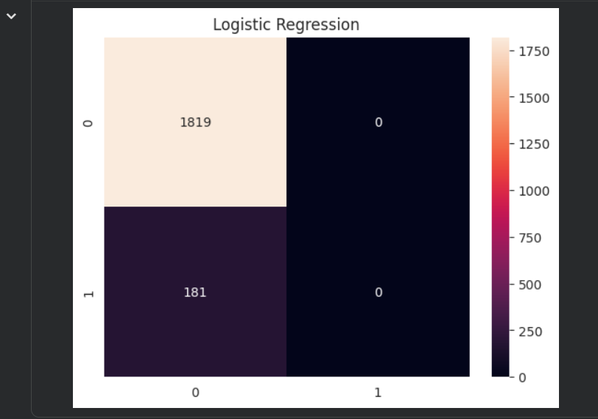
Figure 24_Model Training_5
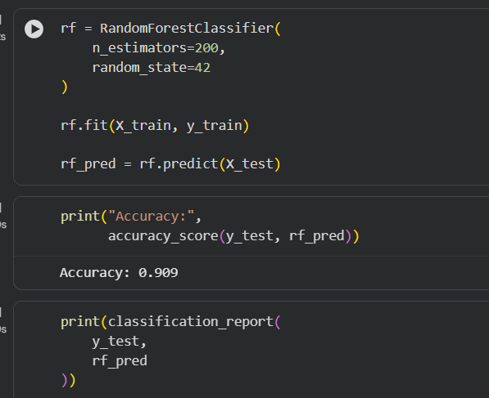
Figure 25_Model Training_6
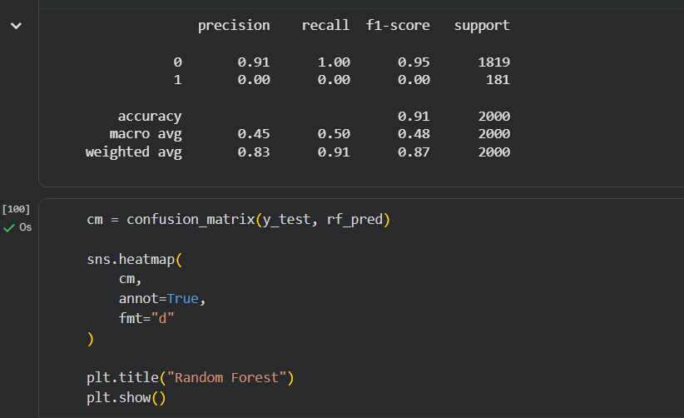
Figure 26_Model Training_7
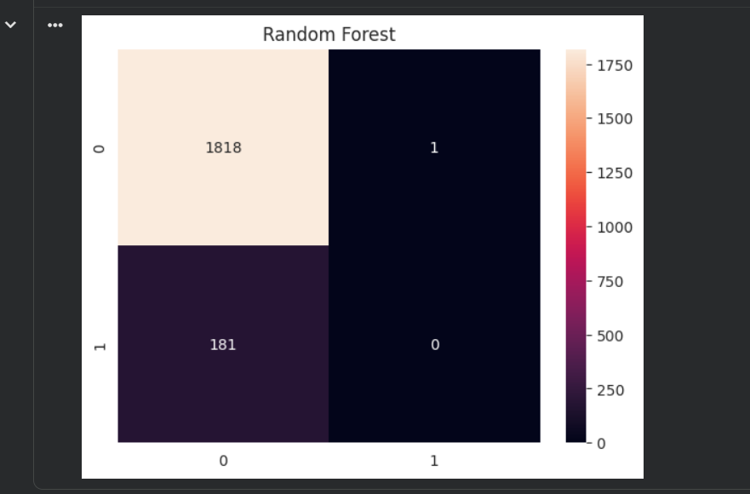
Figure 27_Model Training_8

Screen 4 — Prediction Interface
Users input employee details via a form; the model returns:

Employee Likely to Stay
Employee Likely to Leave

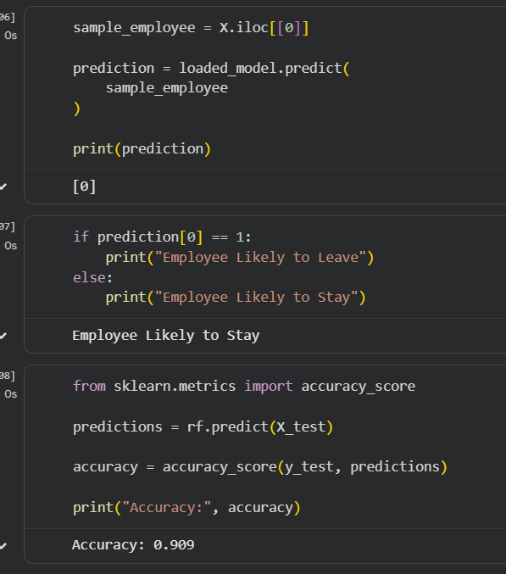
Figure 28_Model_Evaluation_Results_1
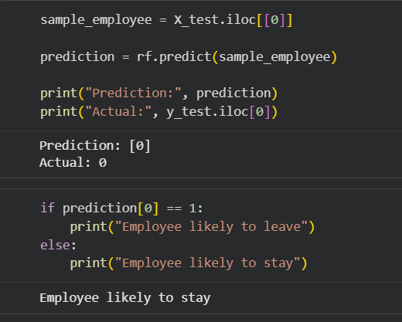
Figure 29_Model_Evaluation_Results_2
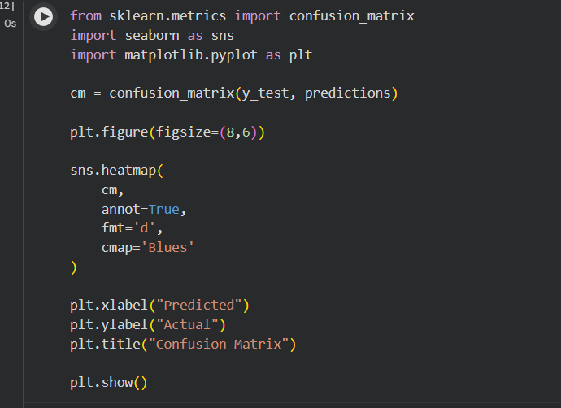
Figure 30_Model_Evaluation_Results_3

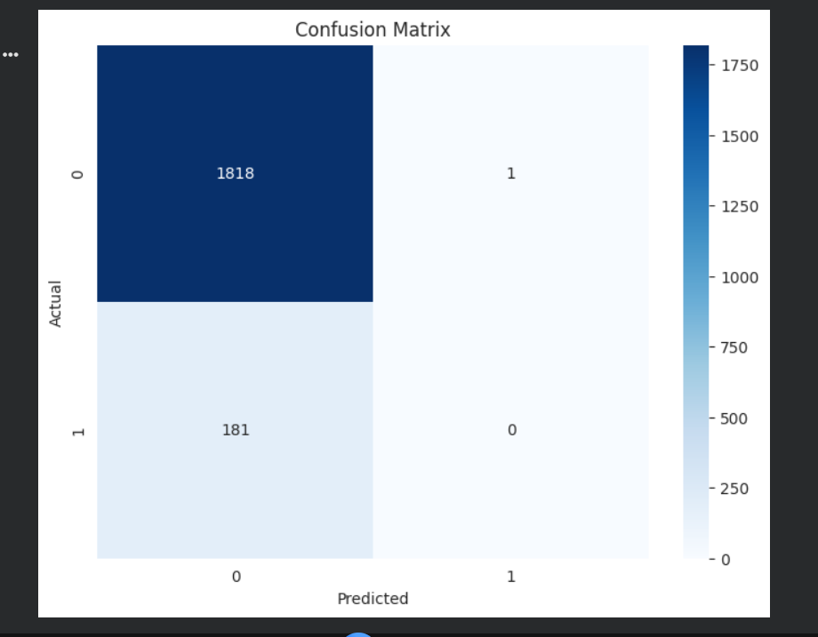
Figure 31_Model_Evaluation_Results_4

Chapter- 5

GitHub & Deployment details

GitHub Repository
The Employee Attrition Prediction project was developed using Python and Jupyter Notebook. The source code, dataset, documentation, and project files can be stored and managed using GitHub for version control and collaboration.

Repository Structure
Employee-Attrition-Prediction/
├── dataset/
├── employee_attrition.csv
├── Employee_Attrition_Prediction.ipynb
├── pics
├── README.md
└── requirements.txt

Deployment Details
The project was implemented and tested in a local development environment using Jupyter Notebook and Python.
Currently, the project has not been deployed to a cloud platform. All data preprocessing, model training, evaluation, and prediction tasks were executed successfully on a local machine.

https://github.com/abdalleofficial/Predicting-Employee-Attrition---Machine-Learning-Project-/tree/main

Chapter- 6

Conclusion & Discussions
Employee attrition prediction represents a high-value application of machine learning within the domain of Human Resource Management. This project demonstrates how structured employee data can be transformed into actionable predictive intelligence, enabling organisations to move from reactive to proactive talent management.

The developed model successfully analyses employee attributes and classifies individuals according to their likelihood of departure. Beyond mere prediction, the model surfaces the underlying drivers of attrition, equipping HR professionals with the contextual information needed to design targeted retention initiatives.

With further refinement, real-time integration, and deployment as an end-user application, this system has the potential to become an indispensable component of modern workforce analytics platforms.

Chapter- 7

Bibliography & References

[1] Kaggle Employee Attrition Prediction Dataset https://www.kaggle.com/datasets/ziya07/employee attrition-prediction-dataset
[2] Scikit-Learn Documentation — https://scikit-learn.org/
[3] Pandas Documentation — https://pandas.pydata.org/
[4] NumPy Documentation — https://numpy.org/
[5] Seaborn Documentation — https://seaborn.pydata.org/
[6] Python Official Documentation — https://docs.python.org/3/
[7] Machine Learning with Python — Various Online Tutorials and Resources

Appendix

Appendix A: Dataset Information
Dataset Name: Employee Attrition Prediction Dataset
Source: Kaggle
Dataset Link: https://www.kaggle.com/datasets/ziya07/employee-attrition-prediction-dataset
Description: The dataset contains employee-related information used to predict employee attrition. It includes demographic, professional, and satisfaction-related features.

Appendix B: Software and Tools Used
- Python 3.x
- Jupyter Notebook
- Pandas
- NumPy
- Matplotlib
- Seaborn
- Scikit-Learn
- GitHub

Appendix C: Machine Learning Models

Logistic Regression
Logistic Regression was used as a baseline classification model to predict employee attrition.

Random Forest Classifier
Random Forest was used to improve prediction performance and compare results with Logistic Regression.

Appendix D: Sample Code

Loading Dataset
import pandas as pd
df = pd.read_csv("employee_attrition.csv")
Logistic Regression
from sklearn.linear_model import LogisticRegression
model = LogisticRegression()
model.fit(X_train, y_train)
Random Forest
from sklearn.ensemble import RandomForestClassifier
rf = RandomForestClassifier()
rf.fit(X_train, y_train)

Appendix E: Project Screenshots
- Dataset Overview
- Exploratory Data Analysis Graphs
- Model Training Results
- Confusion Matrix
- Prediction Results
(Insert screenshots here)

Appendix F: Abbreviations
Abbreviation | Meaning
EDA | Exploratory Data Analysis
ML | Machine Learning
AI | Artificial Intelligence
HR | Human Resources
RF | Random Forest
LR | Logistic Regression

Appendix G: Future Enhancements
- Development of a web application
- Real-time employee prediction system
- Advanced machine learning models
- HR analytics dashboard
- Cloud deployment

